Get Your Genesis 8 Character Into Mixamo, Then Into Unreal Engine 4

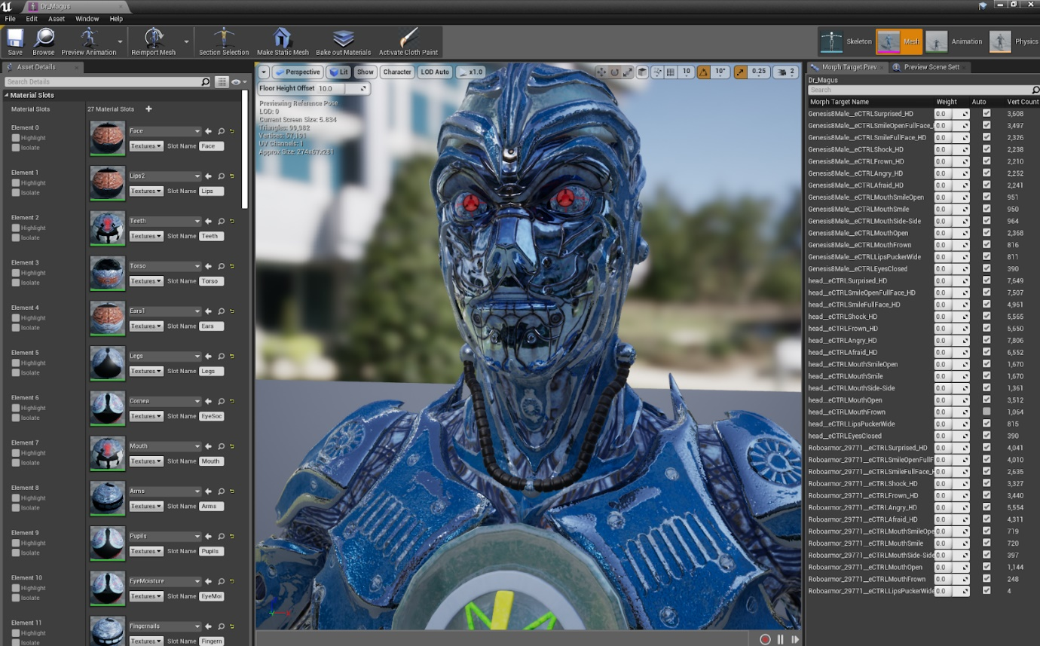

**Step 1:**Import your DAZ Genesis 8 Character Into DAZ Studio

***VERY IMPORTANT STEP:****Click on your character in the scene panel and lower the resolution from HIGH RESOLUTION to BASE RESOLUTION by clicking on the Parameters tab and then mesh resolution. At this time, Mixamo will not accept the high resolution mesh, only the base mesh. You will not lose your details as they will come across in the normal map when we set up the materials in Unreal Engine 4.*

**Step 2:**Export your character in Wavefront OBJ format:

File > Export. Dialog window will open - select from the drop down menu.

Name your character and then select “Save.”

A Dialog Window will open.Use the following settings:

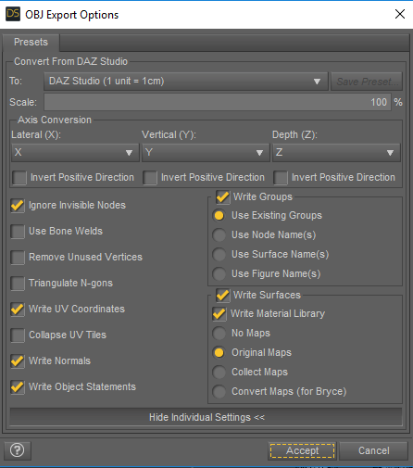

**Step 3:**Delete your DAZ Genesis 8 character from the scene.

**Step 4:**Import your exported OBJ Genesis 8 character.

Step 4.5: Add only the**diffuse materials** to your character. Important: If you add any other textures such as normal, roughness, etc - **Mixamo will reject your character import.**

**Step 5:**Export your Genesis 8 character as an Autodesk FBX file:

(File > Export: Select FBX from the drop down choices).

*As before, choose a name, and select “Save.”*

A Dialog Window will open.Use the following settings:

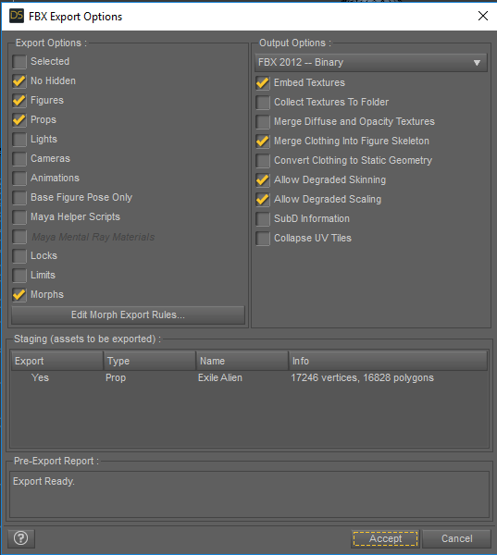

**Step 5:**Go to [www.mixamo.com](http://www.mixamo.com/) - you will need an Adobe account if you don’t already have one in order to use Mixamo. Log in to your account.



**Step 6:**Upload your character *(you can drag your file to the dotted line area if you wish)*

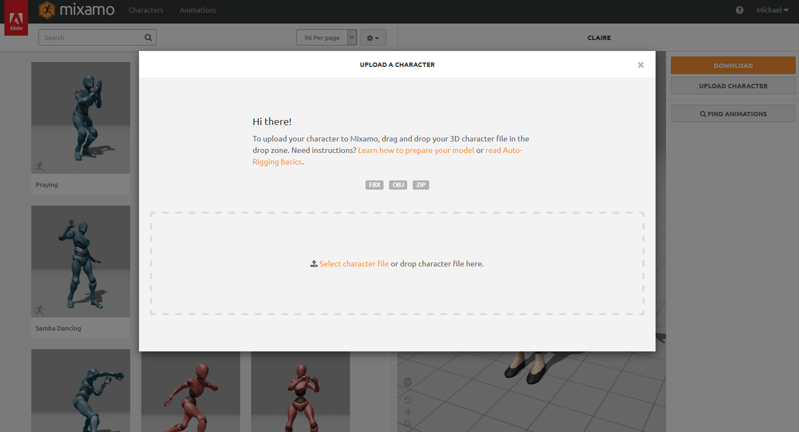

**Step 7:**Prepare your character for Auto-Rig. You will see your character imported.

Click the “Next” button.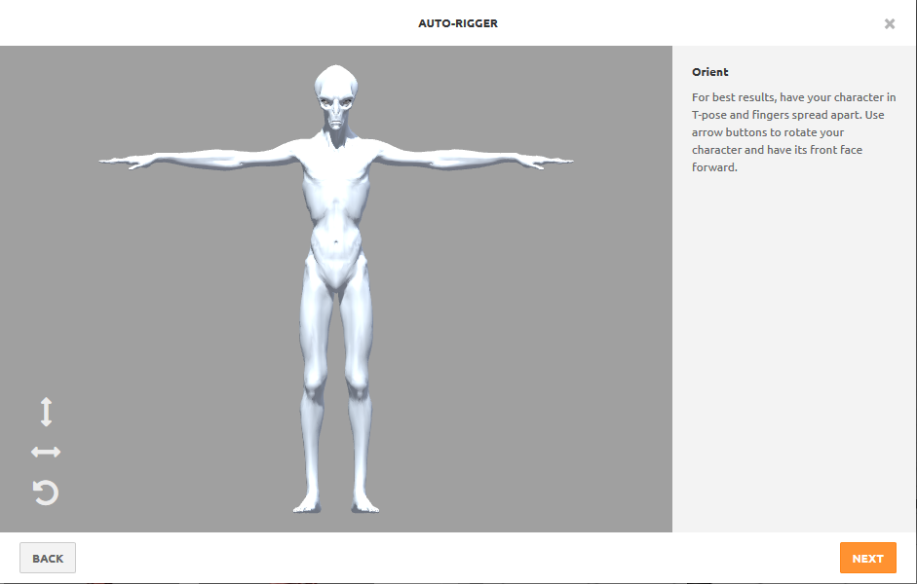

**Step 8:**This screen is where you will prepare your character for Mixamo’s

Auto-Rig Tool.

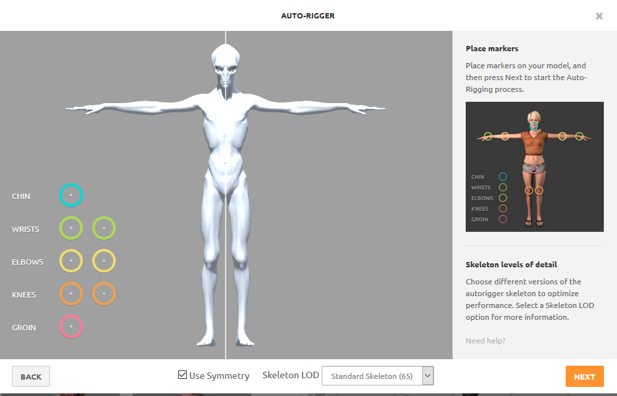

**Step 9:**Position the colored circles by dragging them to the chin, wrists,

Elbows, knees and groin. Then press the “Next” button.

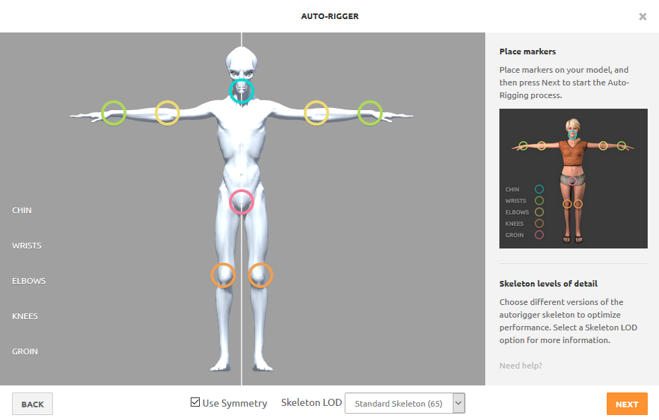

**Step 10:**Mixamo will automatically create a skeletal rig for your character while you watch. It usually takes less than 2 minutes. (Your character will be rotating during this process)

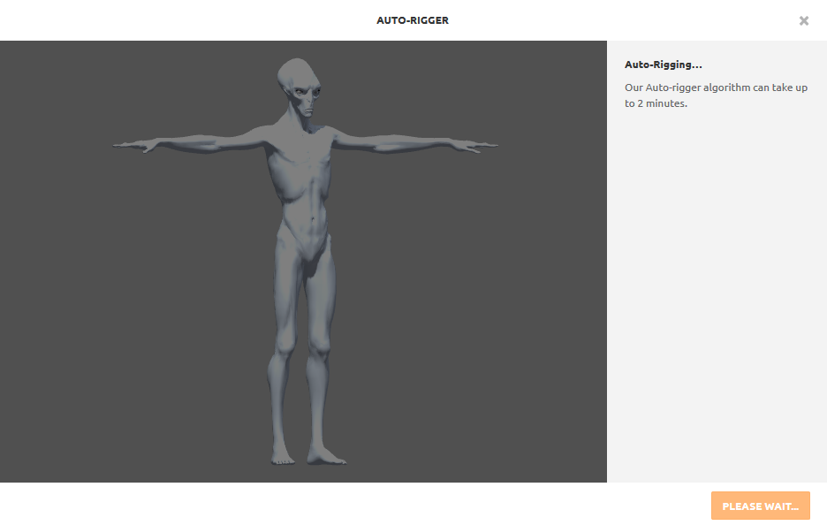

**Step 11:**When Mixamo completes creating your rig you will see the next screen, with a default animation applied. Your character will be looking around.

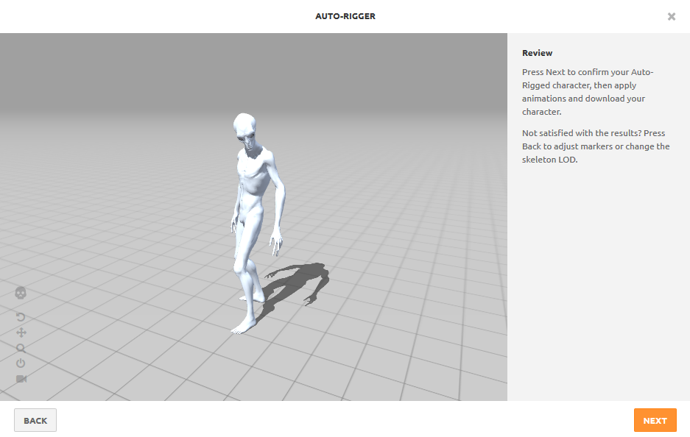

**Step 12:**Click the “Next” button and it will take you to the following screen:

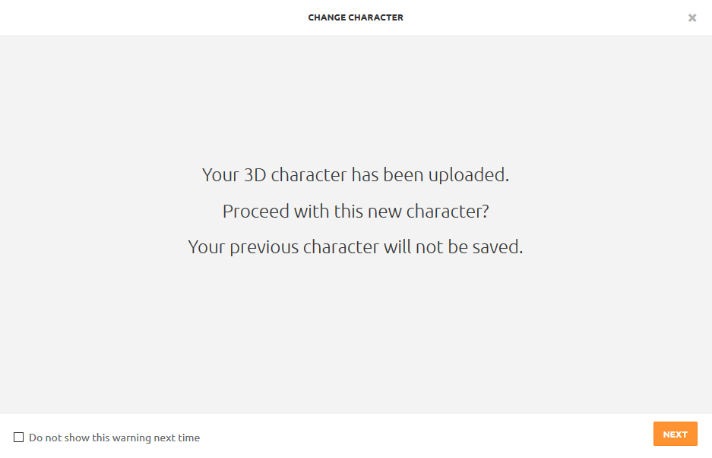

**Step 13:**Click “Next” and it will take you to the following screen:

(Your character will be in a T-Pose, ready to have an animation applied)

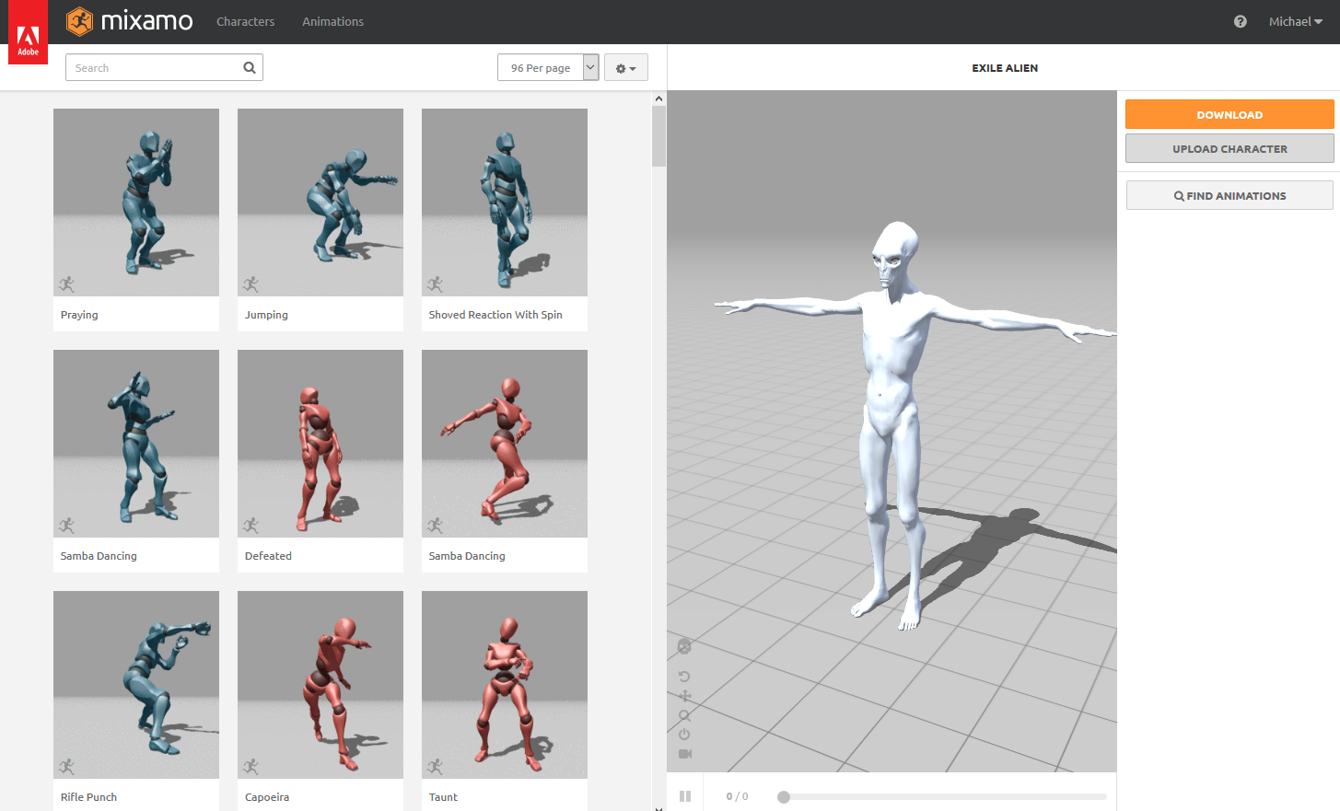

**Step 14:**Apply an animation to your character by clicking on one of the animated previews to the left of your character. There are thousands of professionally created motion-capture animations for you to use. At this time, Mixamo is free to use and download all the animations you would like. You can also search for specific animations like “dance,” “fight,” “lying down,” etc. It’s a blast to apply different animations to your character!

You can click in the larger animation window where your character is and rotate the view in real time during the animation. When you find an animation you like, select the orange DOWNLOAD button.

IMPORTANT: It is necessary for you to download your first animation **WITH SKIN**, so you have the mesh attached to the rig/skeleton Mixamo created for you. After that you can download subsequent animations without skin and apply the animations to your skeleton in Unreal Engine 4. This saves a lot of time during the importing process later in Unreal Engine 4.

**Step 15:**Download your character with animation. Select the download button and choose with skin as mentioned above. Export as FBX. The screen will look like this:

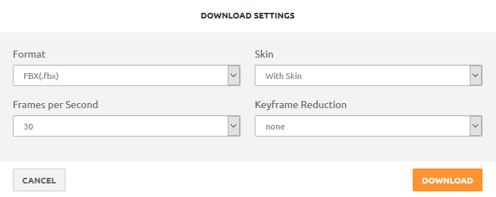

Now you’re ready to import your character along with the Mixamo animations attached into Unreal Engine 4. Let the fun begin!

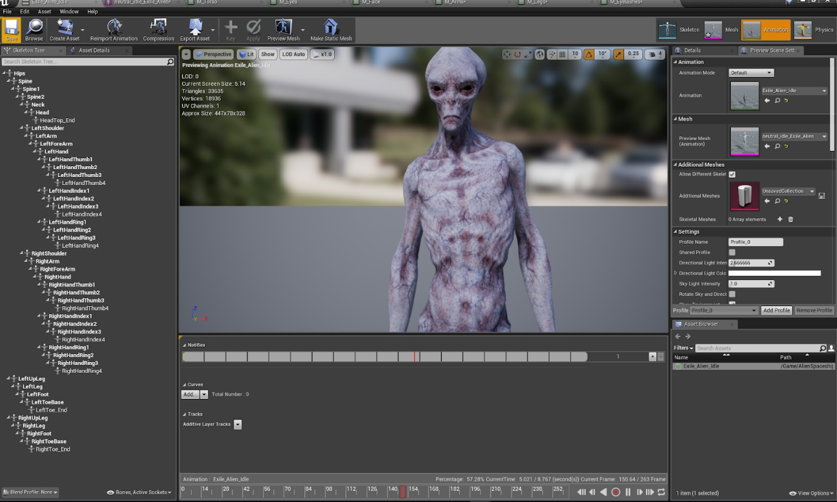

**Step 16:**Import your file into Unreal Engine 4. Use the following settings:

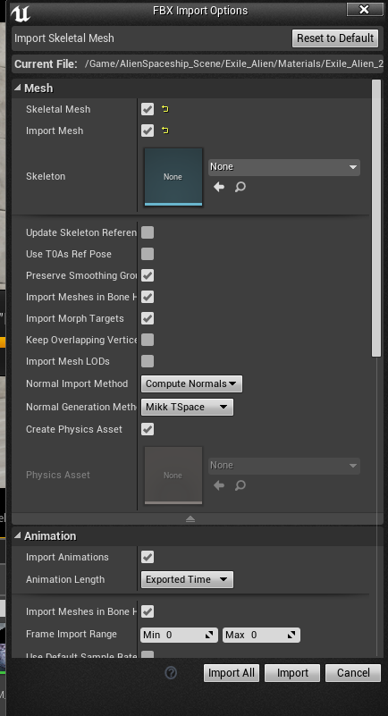

Note: In many cases you may need to import your character at 0.01 scale or it will be gigantic!

**Step 17:**Now that your character is imported into Unreal Engine 4, all you need to do is drag the animation thumbnail into your scene and hit “Play.” Your character will come to life with the animation you got from Mixamo!

**SUMMARY:**

The next step will be to import your texture maps, normal maps, roughness, metallic, etc - then create and assign the materials to your character.

I hope you’ve enjoyed this tutorial and that it helped out a bit. Have fun animating and contact me if you have any questions!

Don’t forget to join the Facebook Group I created just for you at:

<https://www.facebook.com/groups/UnrealEngineTraining/>

Warm regards,



Michael Ricks

Facebook: <https://www.facebook.com/ricks.michael>

Facebook UE4 Training Group: <https://www.facebook.com/groups/UnrealEngineTraining/>

Instagram: <https://www.instagram.com/mikericks2016/>

Email: mikericks@yahoo.com

Resources for this lecture

* [Get DAZ Studio Genesis 8 Characters to Mixamo, Then To Unreal Engine 4.pdf](javascript:void(0))